FORM III
(Refer regulation 7(1))
Bureau of Energy Efficiency
REGISTER CONTAINING LIST OF ACCREDITED ENERGY AUDITORS
Serial Number AEA-160 As on 26/11/2013
A. | Accreditation information in respect of accredited energy auditor
1 | Name of accredited energy auditor | ARVIND B. BHALERAO | 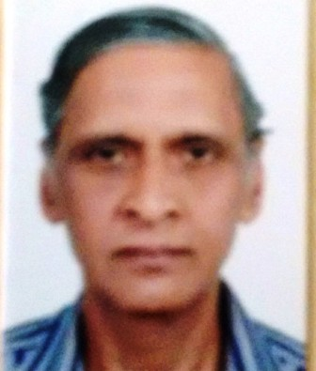
2 | Father’s name | BHASKAR
3 | Date of certification as Energy Manager | 4 th September 2008
4 | Date of passing the examination in “Energy Performance Assessment for Equipment and Utility Systems” | 4 th September 2008
5 | Examination Registration Number of  (i) Energy Manager  (ii) “Energy Performance Assessment for Equipment and Utility Systems” | i ) EA-4144  ii) EA-4144
6 | Certificate Registration Number of  (i) Energy Manager  (ii) “Energy Performance Assessment for Equipment and Utility Systems” | 3517
7 | Date of issue of accreditation certificate | 26/05/2014
8 | Professional postal address with Pin Codes of the accredited energy auditor | Plot No 9, cosmos town, Trimurti nagar  NAGPUR-440022 (MS)
9 | E-mail address | arvbhalerao@gmail.com
10 | Telephone numbers with STD Code  (R)  (O)  Mobile No. | 0712-2221704  0712-2221704  09822281396
11 | Remarks

