BUREAU OF ENERGY EFFICIENCY (BEE)
MINISTRY OF POWER
GOVERNMENT OF INDIA

NEW DELHI, The 21st July, 2015

PRESS RELEASE
BEE signed Implementing Agency Agreement with consortium of RECPDCL-REC-EESL for Partial Risk Guarantee Fund for Energy Efficiency
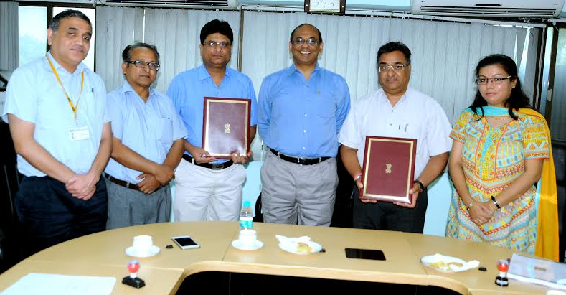
An Agreement for operationalization of Partial Risk Guarantee Fund for Energy Efficiency (PRGFEE) to support energy efficiency projects by addressing credit risk barriers faced in financing ESCOs has been signed between Bureau of Energy Efficiency (BEE) and the REC Power Distribution Company Ltd. (RECPDCL) on behalf of consortium between RECPDCL, REC Ltd. & Energy Efficiency Services Ltd. on 16th July, 2015. The Agreement was signed by Shri Sanjay Seth, Secretary, BEE and Shri Somya Kant, Chief Financial Officer, RECPDCL in the presence of Dr. Ajay Mathur Director General, BEE.

PRGFEE is an innovative financing mechanism under Framework for Energy Efficient Economic Development (FEEED), which is one of the initiatives under National Mission for Enhanced Energy Efficiency. This fund has been constituted by Bureau of Energy Efficiency and Ministry of Power, Government of India. PRGFEE is a risk sharing mechanism to provide financial institutions (Banks/NBFCs) with a partial coverage of risk involved in extending loans for energy efficiency projects.

*******

