FORM III
(Refer regulation 7(1))
Bureau of Energy Efficiency
REGISTER CONTAINING LIST OF ACCREDITED ENERGY AUDITORS

Serial Number (AEA- 0058) As on:- 23rd June, 2014
A. | Accreditation information in respect of accredited energy auditor
1 | Name of accredited energy auditor | AVIJIT CHOUDHURY | 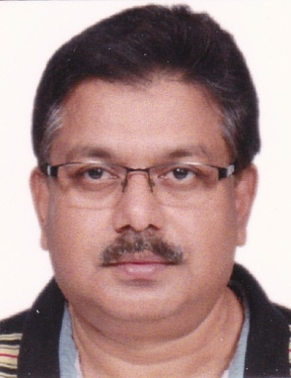  Photograph of the energy auditor
2 | Father’s name | LATE BIJOY KRISHNA CHOUDHURY
3 | Date of certification as Energy Auditor (with Viva) | November, 2006
4 | Date of passing the examination in “Energy Performance Assessment for Equipment and Utility Systems” | November, 2006 (Passed in 1st attempt)
5 | Examination Registration Number of  (i) Energy Manager  (ii) “Energy Performance Assessment for Equipment and Utility Systems” | EA- 5933
6 | Certificate Registration Number of  (i) Energy Manager  (ii) “Energy Performance Assessment for Equipment and Utility Systems” | EA- 5933
7 | Date of issue of accreditation certificate | ( to be filled by BEE)
8 | Professional postal address with Pin Codes of the accredited energy auditor | 632, Golf Vista Apartments, Alpha-II, Greater Noida- 201310
9 | E-mail address | avijit_chnoida25@rediffmail.com
10 | Telephone numbers with STD Code  Mobile No: | 022- 2757 4336 (Head Office)  9711310979
11 | Remarks | RSM is the sixth largest accounting & consulting network in the world.

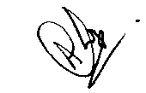
Place: Gr. Noida

Signature:
Date: 29th November, 2016
Name – Avijit Choudhury
Designation – Vice President
RSM GC Advisory Services Pvt. Ltd

