BEE takes a pioneering step under PRGFEE
Mumbai, 03 October 2015

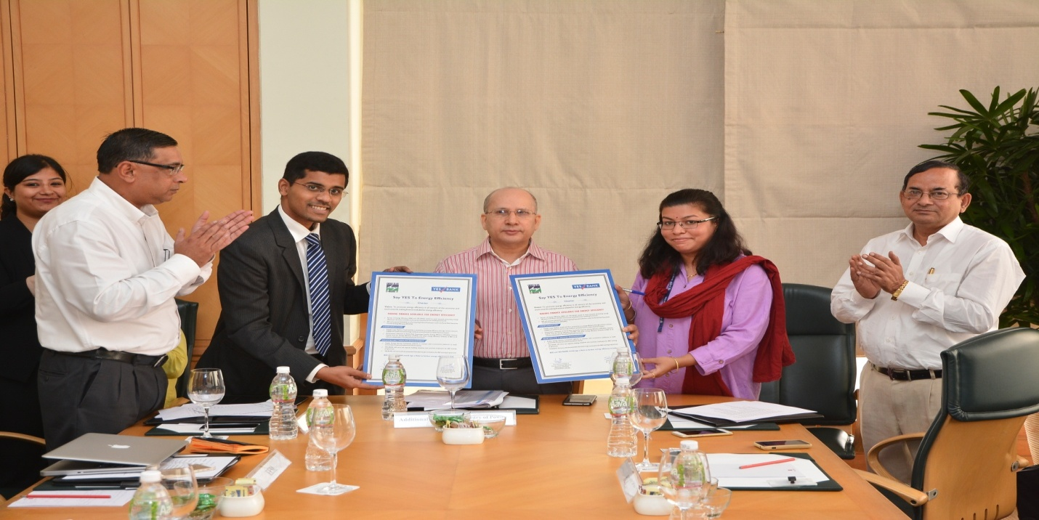

Ministry of Power and Bureau of Energy Efficiency have constituted Partial Risk Guarantee Fund for Energy Efficiency (PRGFEE) for providing financial institutions (Banks/NBFCs) a partial coverage of risk involved in extending loans for energy efficiency projects. Under this programme, Energy Efficiency Services Ltd. (EESL) organized a roundtable meeting with Banks/FIs/ESCOs on 3rd October, 2015 in Mumbai. The meeting was chaired by Mr. B.N Pandey, Additional Secretary, Ministry of Power and attended by various representatives from Banks and ESCOs.

During this meeting a charter was signed between BEE and Yes Bank for empanelment of Participating Financial Institutions (PFIs) under PRGFEE which is expected to set the tone for other Banks/NBFCs to join this league and contribute in promoting Energy Efficiency in India.Speaking on the occasion, the Additional Secretary said that “Funds like PRGFEE and VCFEE shall help Government of India in meeting the voluntary targets set under India’s Intended Nationally Determined Contribution, where India has declared a voluntary goal of reducing the emissions intensity of its GDP by 33 to 35% by 2030 from 2005 levels”.

Ms. NamitaVikas, Senior President and Country Head, Responsible Banking also added that “Yes Bank is glad to partner with Bureau of Energy Efficiency in making ESCOs bankable. As the MSME sector is the cradle for the government’s ‘Make in India’ vision, strengthening and building of the sector on energy efficiency is an integral part of YES BANK’s sustainability approach and we are engaging with stakeholders on all fronts to create maximum impact for climate action in India.”

**********

