Training Workshop for Financial Institutions on Energy Efficiency Financing

New Delhi | December 21, 2017

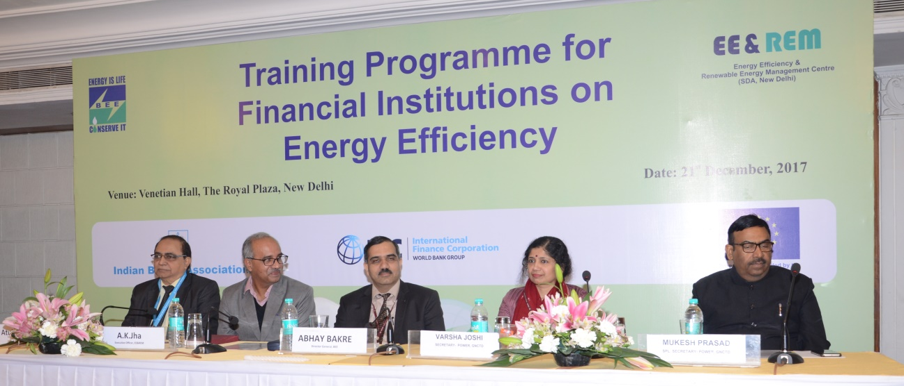
The Bureau of Energy Efficiency (BEE) in collaboration with the Energy Efficiency & Renewable Energy Management Centre (EE&REM Centre) and the Indian Banks’ Association (IBA) organized “Training Workshops for Financial Institutions on Energy Efficiency Financing in India” on 21st December 2017 in New Delhi. The International Finance Corporation (IFC) extended the technical support to the workshop, as part of IFC’s Eco-Cities program in India, supported by the European Union (EU).

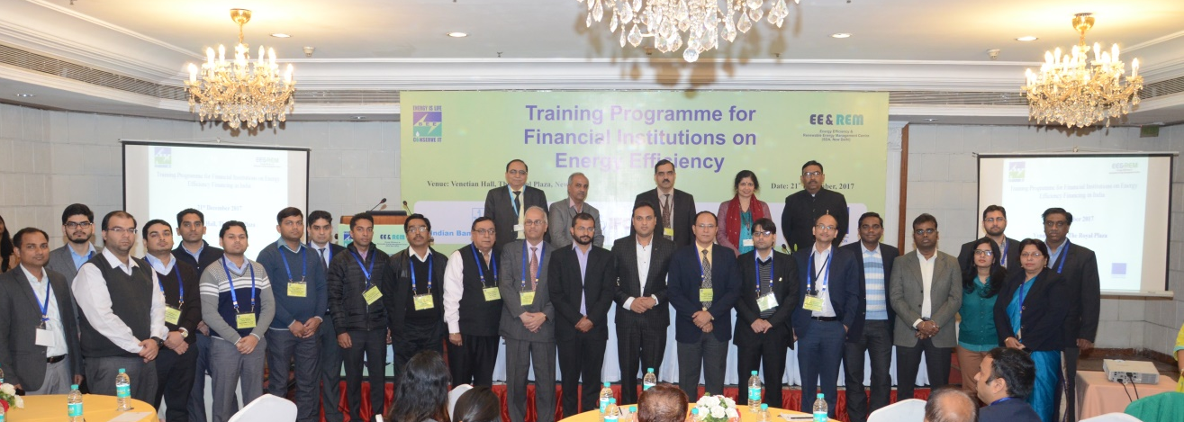
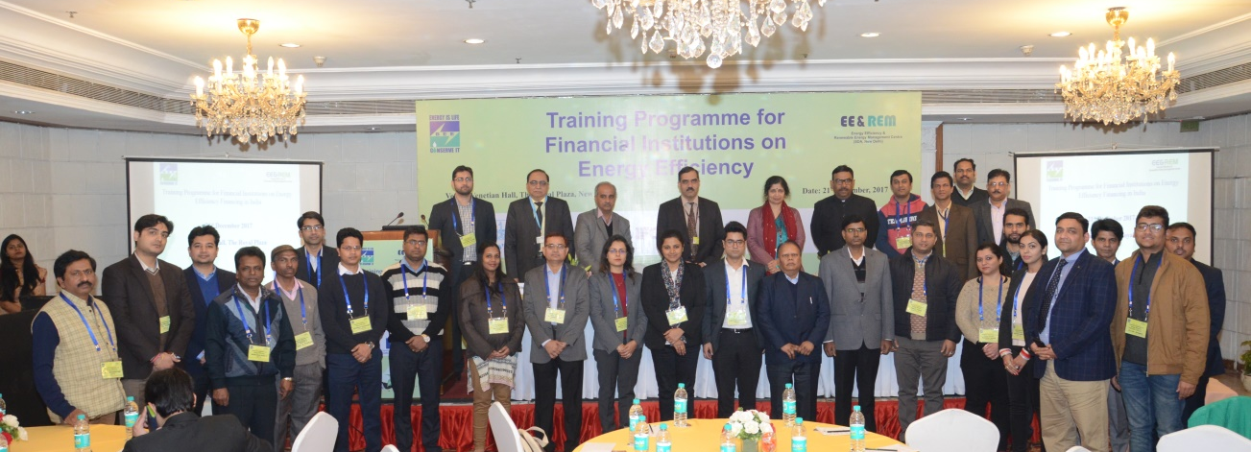
The workshop was inaugurated by Mr. Abhay Bakre, Director General of BEE, in the presence of Ms. Varsha Joshi, Secretary, Power Dept, GNCTD; Mr. Mukesh Prasad, Special Secretary, Power Dept, GNCTD; Mr. Atul Gautam of IBA and Mr. A.K. Jha, Executive Officer of EE&REM Centre. Mr. Abhay Bakre stated that energy efficiency (EE) projects have an investment potential of more than Rs 1,50,000 crore; he also detailed on the various BEE initiatives to promote EE financing.

The workshop was attended by 60 participants from 18 different banks and NBFCs, represented mostly by credit officers, risk officers, and/or project appraisal officers.

The one-day training workshop provided an overview of the technical and economic characteristics of EE projects, business models, financing needs, and risk management approaches. The workshop was also a platform for the participants to interact with energy-efficiency experts on areas such as market opportunities, energy service companies (ESCOs), business models, technical and financial appraisal of projects, measurement and verification (M&V). The workshop also included quiz and activity sessions.

BEE and IFC has already conducted 5 similar workshops in Maharashtra and Karnataka and will further conduct 14 more workshops in different cities across India over a period of next 6-9 months.
