Proceedings

Workshop
on
Partial Risk Guarantee Fund for Energy Efficiency

Friday, March 24, 2017
The Taj Mahal Palace Hotel
Apollo Bandar, Colaba,
Mumbai

Introduction

Bureau of Energy Efficiency (BEE) in partnership with Ministry of Power, Energy Efficiency Services Limited (EESL) and Rural Electrification Corporation- Power Distribution Company Limited (REC-PDCL) held a workshop on the Partial Risk Guarantee Fund for Energy Efficiency (PRGFEE) in Mumbai on March 24, 2017. The Workshop was attended by several representatives of Financial Institutions and Energy Service Companies (ESCOs) to understand the various tenets of the scheme. During the workshop, the guests of honour launched a logo for the PRGFEE scheme, its marketing material and the Operations Manual.

The Consultations were fruitful and various recommendations of the Financial Institutions and ESCOs were taken. These recommendations will be deliberated upon by Bureau of Energy Efficiency and the Implementation Agency including EESL and REC-PDCL to strengthen the scheme and remove any anomalies. A list of the attendees is provided in Annexure – I.

Programme Schedule
Time | Activity | Speaker
10:30 - 11:00 | Registration & Tea
11:00 - 11:05 | Opening remarks | Shri. Milind Deore  Energy Economist, BEE
11:05 - 11:10 | Key Note Address | Shri Abhay Bakre  Director General, BEE
11:10 - 11: 15 | Launch of PRGFEE Logo, Operations Manual and Marketing Material | Shri B.P Pandey, IAS  Special Secretary, Ministry of Power
11:15 - 11: 25 | Inaugural Address | Shri B.P Pandey, IAS  Special Secretary, Ministry of Power
11: 25 - 11:45 | Prospective Projects under PRGFEE | Shri S.P Garnaik  Chief General Manager (Tech), EESL
11:45 - 12:00 | Operational Guidelines of PRGFEE | Shri Mukund Kumar,  Senior Executive, REC-PDCL
12:00 - 12:15 | Impact of PRGFEE Scheme  A perspective from ESCOs | Shri Milind Chittawar  CEO-SEETech
12:15 - 12:30 | Perspective from State Government Agency | Shri Hemant Patil  Manager, Energy Conservation, Maharashtra Energy Development Agency
12:30 - 12:45 | Impact of PRGFEE Scheme  A perspective from Banks | Yes Bank, IDBI, State Bank of India
12:45 - 13: 10 | Open House Discussion
13:10 - 13: 15 | Vote of Thanks | Ms. Anita Kumar,  Edelman India
13:15 pm onwards | Lunch and Networking

Inaugural session:

Shri Milind Deore, Energy Economist, Bureau of Energy Efficiency
- Shri Milind Deore, welcomed the guests of honour Shri B.P. Pandey, Special Secretary, Ministry of Power and Shri Abhay Bakre, Director General, Bureau of Energy Efficiency, officials from MEDA, EESL and the audience
- Mr. Milind Deore gave an overview of the PRGFEE scheme and spoke about the hurdles that the team has overcome in formalizing it
- Mr. Deore also thanked Shri B.P. Pandey (IAS), Special Secretary, Ministry of Power for being instrumental in the formalization of the PRGFEE scheme. Mr. Deore also highlighted how Shri Pandey has been instrumental in making the scheme more simple and easier for adoption

Shri Abhay Bakre, Director General, Bureau of Energy Efficiency
- Shri Abhay Bakre, Director General, Bureau of Energy Efficiency highlighted that all institutions are aware of the significance of energy efficiency and energy conservation
- Today, there is technology, market and sufficient demand, a thrust for transformation may be required by the government & eventually the industry
- In this scenario, the role of financial institutions becomes imperative. An enabling framework should be made available to ESCOs and hosts to come forward and implement projects
- Secondly, awareness is equally important for understanding how to adopt energy efficiency projects. This is also a joint effort led by ESCOs for hosts to make the adoption of energy efficiency projects swifter
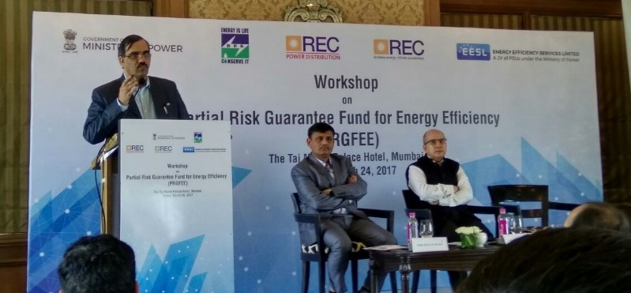
- Shri Bakre highlighted that financial mechanisms like PRGFEE and Venture Capital Fund for Energy Efficiency (VCFEE) should be leveraged by banks so that consumers are not deprived of opportunities to become energy efficient. This workshop is a great opportunity to share perspectives
Shri Abhay Bakre, Director General, BEE addressing the audience at the workshop

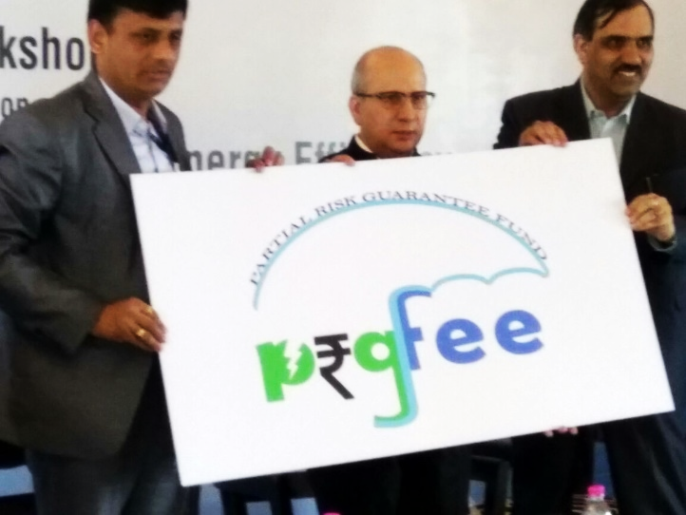
Unveiling of the Logo, Brochure & The Operations Manual

The Chief Guests unveiled the PRGFEE logo, the PRGFEE Brochure and the PRGFEE Operations Manual amidst the audience, thereby giving the scheme an identity and guidelines.

L to R: Shri Milind DEore, Energy Economist, BEE; Shri B.P. Pandey, Special Secretary, Ministry of Power and Shri Abhay Bakre, Director General, BEE

Address by Shri B.P. Pandey, Special Secretary, Ministry of Power

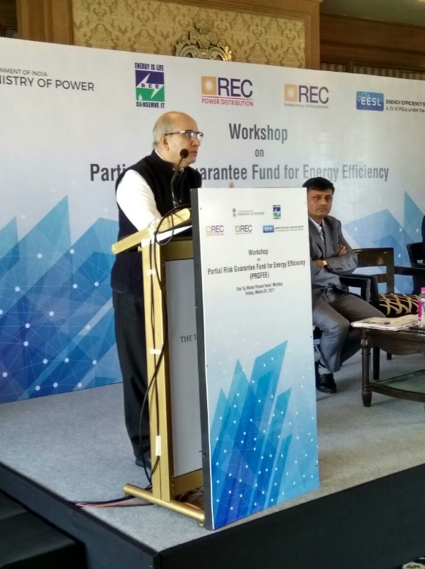
- Last year we consumed 1.1 trillion units of power which is a 7% growth from the last year. Energy efficiency was a crucial factor to bring down the consumption considering our growth
- Globally we are committed to have a cleaner environment while dependence on our power will continue to increase
- Mobilizing ESCOs and giving comfort to Financial Institutions is the most important factor
- Buildings are to be included in the PAT II.
- Agriculture is another sector where there is immense potential
- With the Hon’ble Prime Minister having launched several innovative programmes like Startup India, we can have synergies and integrate such financing instruments for larger adoption
- I hope the programme regulations are periodically amended
Shri B.P. Pandey, Special Secretary, Ministry of Power addressing the audience at the workshop

Technical session

Address by Shri S.P. Garnaik, Chief General Manager (T), Energy Efficiency Service Limited

Session on Prospective Projects under PRGFEE
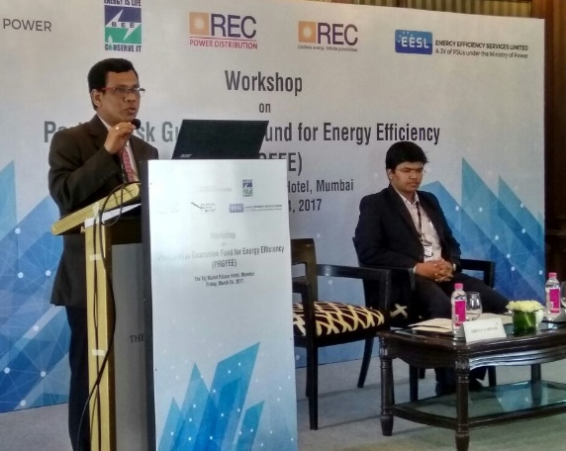
Shri Garnaik apprised the audience of the trajectory of energy conservation in the country and how the Energy Conservation Act in 2002 was pivotal in providing a direction to energy efficiency. With the introduction of National Action Plan for Climate Change (NAPCC) and one of its mission – National Mission for Enhanced Energy Efficiency (NMEEE) got approved in 2008, there was a structure to accelerate energy efficiency in a lower cost and bring about market transformation in the country.

Shri S.P. Garnaik, Chief General Manager (T), EESL addressing the audience at the workshop

Today, ESCOs are functioning in a significant manner and there is a need for schemes like PRGFEE to provide the additional thrust and for the sector to flourish. There needs to be an organization that takes the investment risk, thereby setting the pace for all ESCOs to emulate Shri Garnaik stated that EESL was established with this intent.

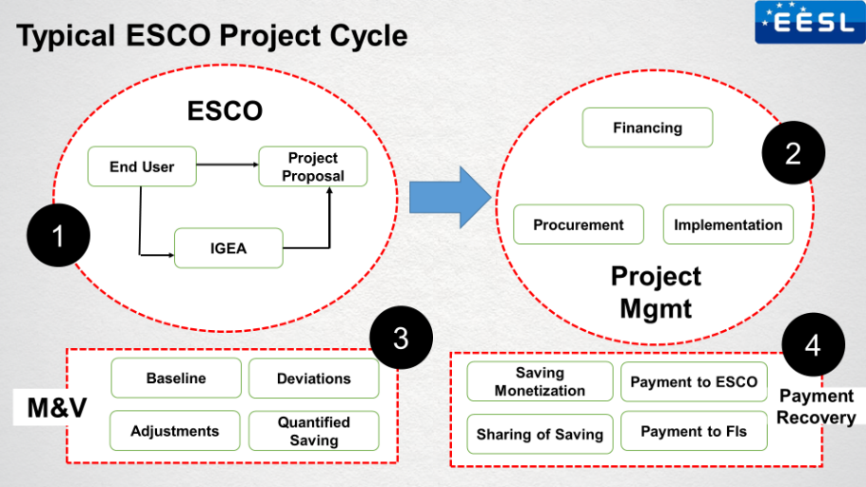
Further, Shri Garnaik explained to the audience a standard ESCO Project Cycle. A detailed analysis was provided on the various stages of an energy efficiency project – proposal, financing, implementation, M&V and payment recovery. The session equipped the audience of how many processes can be customized to improve and simplify the project and convince clients. These processes will bring in confidence of investment

As EESL has been mandated with the technical evaluation of projects under the PRGFEE, Mr. Garnaik advised that project proposals seeking a guarantee under PRGFEE, should be proven and widely available technology. Secondly, subjectivity in savings should be avoided and processes like the ‘deemed savings’ approach is more acceptable. Proposals with deviations and lower payback period (not more than 3 years) and project life should be attractive for wider acceptance.

Shri Garnaik also apprised the audience of the new technology under projects initiated by EESL like motors, compressors, LED street lighting, etc.

Shri Mukund Kumar, Senior Executive, REC-PDCL

Session on Operational Guidelines of PRGFEE

Shri Mukund Kumar provided an overview of the guarantee scheme and its basic elements. The following key points were highlighted in Shri Mukund Kumar’s presentation:

- The size of the PRGFEE Fund is INR 312 crores
- PRGFEE will guarantee upto a maximum of 50% of the total amount sanctioned by the Bank to a maximum of INR 10 crore
- Minimum amount of loan should be INR 5 lakhs, but there is no cap on the maximum amount. There is however a cap on the guarantee, upto INR 10 crore
- Due to the timely intervention by the Ministry of Power, the Application Fee has now been reduced to 0.1% of the amount to be guaranteed
- After evaluation and approval, 1% of the amount guaranteed would be required to be provided as Guarantee Fees, with a special rebate of 0.5% for women entrepreneur
- The Guarantee Fee shall be reimbursed to the Financial Institutions on the successful completion of the project along with the expenses incurred by the PFI for the techno-economic evaluation of projects
- In case of default, there is a facility of first loss subject to a maximum of 10%
- Only BEE empaneled ESCOs can avail the PRGFEE guarantee. ESCOs who are in the process of empanelment can also obtain the guarantee

Further, Shri Mukund Kumar explained the process of seeking the guarantee through the below sequence

Shri Milind Chittawar, CEO, SEETech Solutions

- Shri Milind Chitwara- CEO, SEETech Solutions thanked EESL for providing an opportunity for ESCOs to share their perspectives on the current scenario for ESCO’s financing and presented a video to the audience highlighting the work that has been done by SEETech solutions
- He highlighted his experience so far in the Energy efficiency space and stated that customers are looking at reducing energy costs and not just energy audits. Highlighting some difficulties in receiving funding for a project, Mr. Chitwara also stated that CGTSMSE scheme (before PRGFEE was available) is available with SIDBI which is ‘collateral free’ but has a limit till 1 crore
- Mr. Chitwara highlighted few drawbacks in the scheme and stated that ‘this scheme has to compete with other available government schemes only’ as ESCOs only look for best options for financing
- As for the project management perspective, ESCOs spend several man hours for developing detailed IGEA reports which are not understood by the end-user or the Banks. This time is a cost to the ESCO, leading to derailment of ongoing project work. There is a need to simplify procedures
- Proven technology is subjective and may differ from ESCO to ESCO. Therefore, seeking a guarantee based on proven technology may not be the right approach
- He also stated the banks do not have confidence in ESCOs and this scheme is comfortable only for banks and not ESCOs as it makes them go back to ways of funding where collaterals are needed despite having availability of schemes which are ‘collateral free’ and with competitive interest rates

Shri Hemant Patil, Manager, Energy Conservation, Maharashtra Energy Development Agency (MEDA)

- Shri Hemant Patil, Manager, Energy Conservation, Maharashtra Energy Development Agency (MEDA) spoke about state initiatives taken by Government of Maharashtra and MEDA which has a scheme for energy efficiency since 1985 which is still in function and more than 1000 energy audits have been done under this scheme in different sectors
- Shri Patil stated that MEDA has submitted a policy in January 2016 to the state government, proposing a strong financial assistance for the ESCO model for Residential Sector, Commercial Sector, Commercial Buildings, and Industries. Mr. Patil spoke about the various features of the proposed scheme and stated that the Chief Secretary of the state has approved it and will be launched soon. For development of ESCOs and Energy Auditors, MEDA has proposed a scheme for them to buy the sophisticated instruments for their capacity building.
- He highlighted that schemes and initiatives are important to help ESCOs to counter the challenges involved for project financing

Representative of YES Bank
- The representative said that- YES Bank was one of the first banks in the country to disburse loans through such a guarantee.
- He further highlighted that energy efficiency financing a new concept for as they do not have the technical knowledge. The Banks will be dependent on the Implementing Agencies for knowledge and guidance
- During his address, he shared some challenges in financing ESCO projects through Partial Risk Sharing Fund (PRSF) scheme with SIDBI.
- He highlighted that while the ESCO qualifies under the Small & Medium Enterprise, once the ESCO purchases equipment, they cease to be SME due to the high value. This leaves the Banks in a situation where neither the ESCO nor the host can be categorized as SME
- He is confident that these teething issues will be resolved by the Ministry
- He also responded to questions pertaining to the PRSF scheme from the audience

Shri Dinesh Prithvi, DGM, State Bank of India
- Mr. Dinesh Prithvi, DGM, SBI, Mumbai shared that there is not much clarity on the scheme and the management is not sure how his scheme would be advantageous to the Bank
- He further stated that as the loan could be used for both energy efficiency and renewable energy, it is difficult for the Bank to assess the difference during application
- Thirdly, Shri Prthvi stated that the scheme is only valid for close to 150 ESCOs empaneled with BEE, which is equivalent to 150 potential accounts for the Bank. For this scheme, banks would have to institutionalise procedures, develop internal software and MIS for energy efficiency projects. The process is too cumbersome for only 150 accounts
- ESCO representatives stated that despite the fact that there are only 150 accounts, the value of the projects would be high, therefore benefiting the Banks
- He stated that only after getting some clarity, they will seek to get empaneled with this scheme
- Shri B.P. Pandey recommended that measures for building the capacity of Banks should be undertaken

Shri Satya Narayan Palai, Associate Vice President, Business Development, Reliance Infrastructure
- Shri Satya Narayan Palai shared his perspective from a user point of view. He stated that there are a lot of opportunities in the energy saving scenario in industries.
- Shri Palai highlighted that processes like for financing process or technological solutions should be made simple because user needs quick information on benefits energy cost reductions that will improve productivity

Naresh Baral, General Manager, IDBI Bank Limited
- Speaking from the user perspective, Shri Baral was confident that PRGFEE scheme will support projects for lower project value

Q&A Session

- After 75% recovery of the guarantee will be given within 60 days, when will the Banks obtain the balance payments?
- Shri Mukund Kumar stated that the balance will be transferred once the recovery proceedings are complete with the ESCO and the proportionate amount is transferred to the PRGFEE account, it indicates the closure of recovery

- For how many projects can any ESCO seek the guarantee?
- Shri Mukund Kumar stated there is no cap on the number of projects that can be applied for the PRGFEE scheme

Vote of Thanks

- Ms. Anita Kumar, concluded the workshop with a note of thanks to the panelists for taking the time out to provide insights on the scheme and to highlight the importance of energy efficiency financing in the country

***

Annexure I

List of Participants

Attendee List - PRGFEE Roundtable
S.No | Name | Designation | Organisation
1 | Mahesh Patankar | Managing Director | MP Ensystems
2 | Sonia Shukla | Program Manager
3 | Dinesh Pruthi | Deputy General Manager (Sustainability) | State Bank of India
4 | Bibhu R Parida | GM - Sales & Marketing | Hi-Tech Systems & Services Ltd.
5 | Vrunda K | Executive Vice President - Finance | eSmart Energy Solutions Private Limited
6 | Subhash Soni | Director
7 | Milind Chittawar | CEO | SEEtech
8 | Shankar Sapaliga | Senior Consultant HVAC | International Copper Association India
9 | Alok Singh | Assistant Vice President - Project Management Group | Reliance Infrastructure Limited
10 | Satya Narayan Palai | AVP- Business Development
11 | Vishvam Oza | Associate Director - SME | IDFC Bank
12 | Selvaraj K | Commercial & Wholesale Banking Legal Head
13 | Dr. Tarini Prasad Sahoo | Program Officer | Institute for Sustainable Communities
14 | Amit Kumar Singh Parihar | Program Officer
15 | Naresh Baral | General Manager | IDBI Bank Limited
16 | Vineet Sahasrabuddhe | Project Engineer | Le Energyca ES Pvt Ltd
17 | R.L. Bhutiani | Sr. Consultant | Certification Engineers International Limited
18 | Nishant Dubey | Chief Manager | Corporation Bank
19 | Bhagwan Shirsekar |  | Lighting Environment Design
20 | Ashutosh Tandon | Finance & Markets Group Practice - South Asia | World Bank Group
21 | Aishwarya Patankar | Analyst | Idam Infrastructure Advisory Pvt Ltd
22 | Craig Miranda | Relationship Manager | Tata Cleantech Capital Limited
23 | SP Garnaik | Chief General Manager - Technical | Energy Efficiency Services Limited
24 | Dipak Kokate | Regional Manager - Maharashtra
25 | Sathiya Narayan S | Assistant Manager - Technical
26 | Pappu Patel | Assistant Manager - Finance
27 | Kuldeep Kumar | Manager Finance
28 | Prashant Kumar Yadav | Assistant Manager - Finance
29 | Manoj More | Engineer
30 | Suman Nabakumar Pal | Product Engineer
31 | Mayur Rathod | Engineer

